
SGT122/115 issues Windows 7 (32/64 bit)
If you experience issues with a USB device not being recognized under Windows 7, there might be a simple solution to solve this. The Stanley Global SGT115 and SGT122 are susceptible to this issue and may be falsely recognized as an eHome Infrared Receiver (USBCIR) under Windows 7. The device works great using Windows Vista or even the Windows 7 pre-release versions. Unfortunately, recent Windows 7 updates have created an issue.
A quick look into the Device Manager will show that the device is recognized as eHome Infrared Receiver (USBCIR). Windows 7 won’t give any notice that the installation of the driver failed or that the device is not ready to use. It will simply not work.
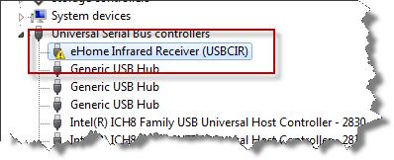
This seems to be known problem, however, there is no need to wait for a Software Update from Microsoft. The solution is to manually choose the device.
- Start Device Manager
- Right-click the eHome Infrared Receiver (USBCIR) entry
- Select Update Driver Software
- Choose Browse my computer for driver software
- Choose Let me pick from a list of device drivers on my computer
- Make sure the Show compatible hardware box is checked
- Select the USB Composite Device and you are done
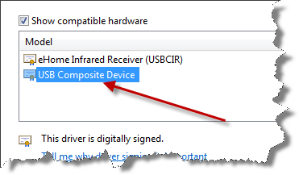
After a few seconds the driver should be installed and the device should be ready.
