Click Start, Select Run, and then type: regedit in the Run line. Back up your registry before proceeding. Instructions: http://windowsxp.mvps.org/registry.htm
Navigate down to: HKEY_LOCAL_MACHINE\SYSTEM\CurrentControlSet\Services\SCardSvr
Mirror your computer to these settings.
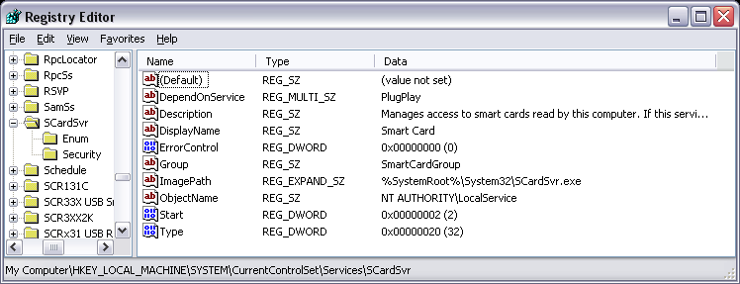

Go to the enum folder to verify this information.
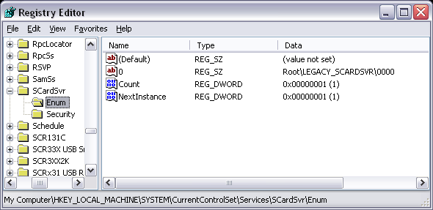

Go to Security folder to verify this information
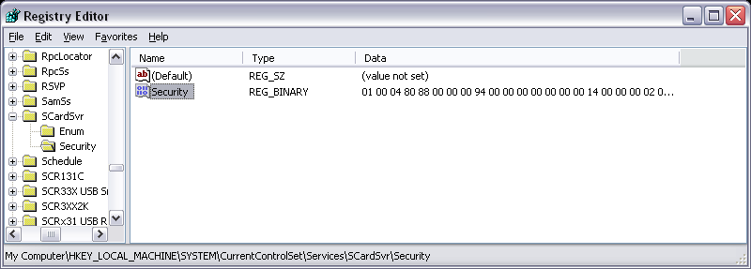

Here is the binary information for the Security folder above. Follow the numbers down the left side.
