Click Start, type: regedit.exe in the white search box. Back up your registry before proceeding. Instructions: http://windowsxp.mvps.org/registry.htm
Navigate down to: HKEY_LOCAL_MACHINE\SYSTEM\CurrentControlSet\Services\SCardSvr
Mirror your computer to these settings.
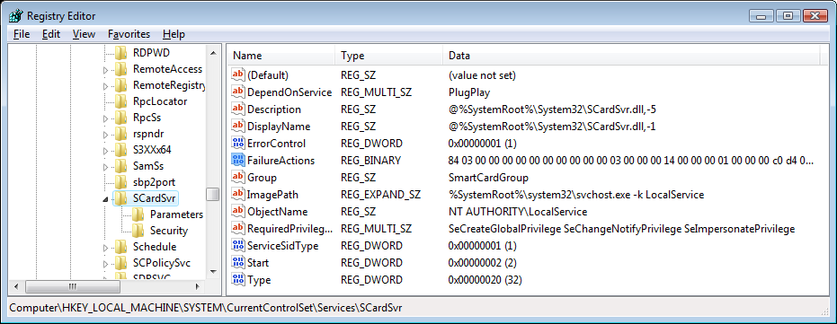
FailureActions Data
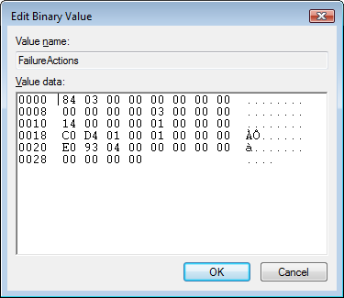

Go to the Parameters folder to verify this information.
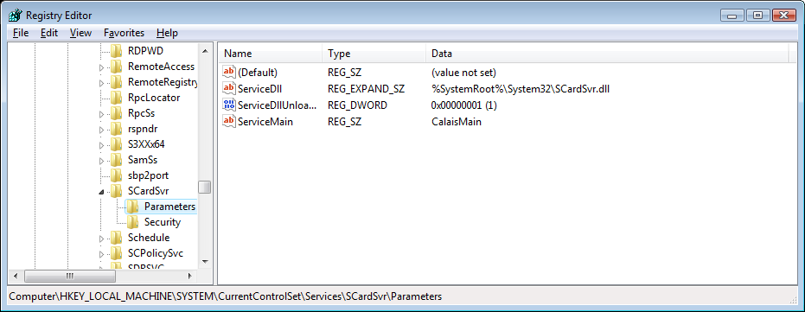

Go to Security folder to verify this information
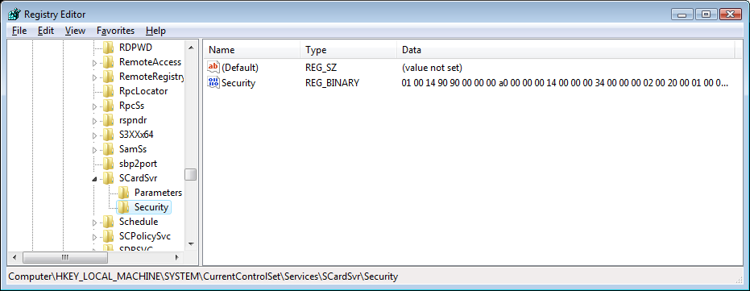

Here is the binary information for the Security folder. Follow the numbers down the left side.
