Errors when trying to sign a form in Lotus Forms or Pure Edge viewer:
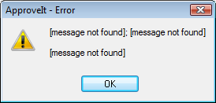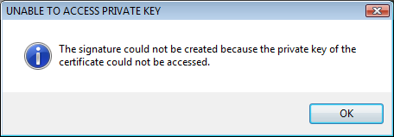
Error when opening ApproveIt Configuration:
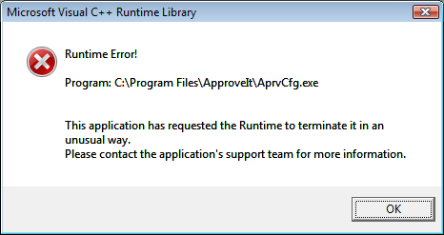
RESOLUTION for Government Computers (Vista):
1. Logon as administrator. Give admin rights to user.

2. Uninstall ApproveIt – if no uninstall option under programs and features, install ApproveIT 6.1, then uninstall it. Delete ApproveIt folder under Program files.

3. Uninstall PureEdge or Lotus Forms. Delete PureEdge/Lotus Forms folder in Program files.

4. Delete PureEdge from registry (Run > regedit > HKEY_CURRENT_USER > SOFTWARE > PUREEDGE)

5. Copy ApproveIt & Lotus Forms install folders to local hard drive for install later.

6. Go to Control panel, User accounts and turn off UAC, REBOOT and remove LAN cable (or disable local area connection) so that UAC won’t turn back on.

7. Let user log in with CAC, using cache account.

8. While user is logged in as admin, install Lotus Forms 3.5 (Right click on AGMinst.exe, run as administrator) or Pure Edge viewer 6.5. (Double click PEViewer650DODJ12……)

9. Install ApproveIt 6.1. (Note: Double clicking the AGMinst.exe won’t work so go to the “source” folder and right click on “setup.msi”, select “install”, and then when prompted, enter the following serial number: w7ktkq-579834, Typical install)

10. Reconnect LAN cable/re-enable network connection, REBOOT.

11. Go to Control panel, programs and features, ApproveIt and “Change” take away red X from Lotus Forms and other programs a user may need to sign digitally so that ApproveIt will work with those programs.

12. Go to All programs, ApproveIt desktop, ApproveIt configuration and make sure “Enable smartcard signing” is checked. On the rare occasion that the “sign” button is grayed out, simply go back to Control panel, select ApproveIt and click on “repair.”

13. Test digital signing

14. Go to Control panel, User accounts and turn UAC back on

15. Take away users admin rights.

16. Reboot and test digital signing.

