NOTE: Before using the configuration instructions make sure you have the DoD root certificates installed on the computer. https://militarycac.com/dodcerts.htm
Configure your Mail account profile in Outlook 2010 by do the following:
- Go to Control Panel

- Click on the Mail icon (if using Windows 7, click on User Accounts and Family Safety to get to the Mail icon)

- Click on Show Profiles
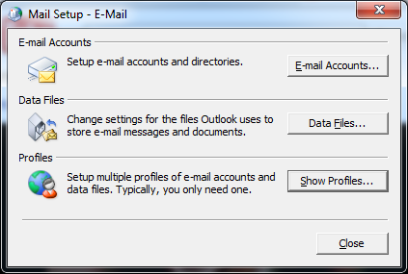

- You will have two options:
- You can add the Beta Mail account mailbox to an existing Outlook profile (Outlook 2010 allows you to view multiple exchange e-mail accounts under one profile). Select the Profile you want to add the mailbox to and click on Properties.

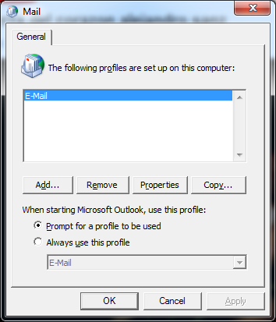

Click on E-mail Accounts

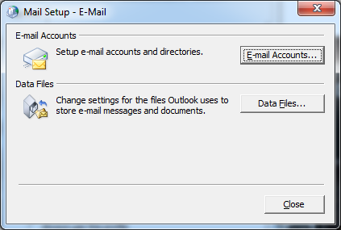
In the E-mail tab, click on New... Continue to step 5
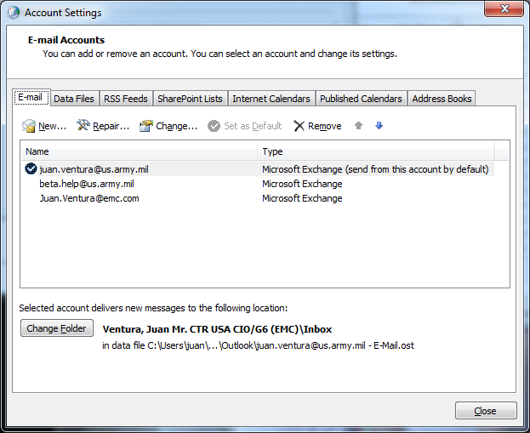

- The second option is to create a New profile, click on Add. Enter the name for the Profile and Click OK
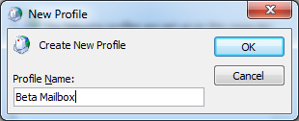

- Click on Manually configure server settings or additional server types and then click Next
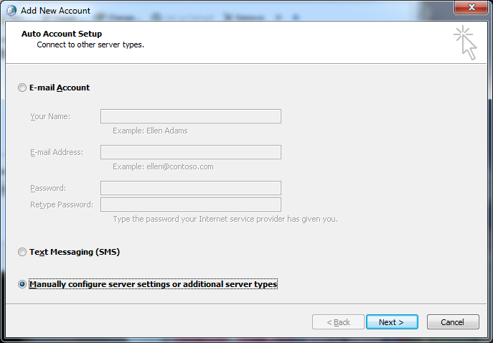

- Click on Microsoft Exchange or compatible service and click Next
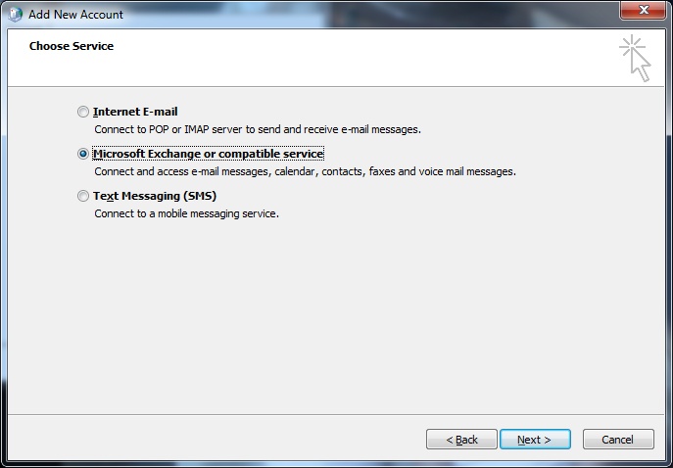

- In the Server field enter: mail.beta.army.mil
In the User Name field enter your beta mail user id: username@us.army.mil
Click More Settings

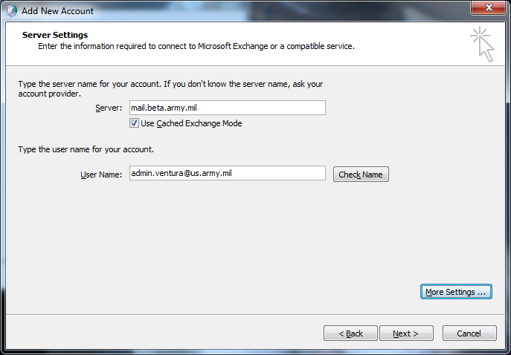

- Click the Connection Tab
In the Outlook Anywhere section check the Connect to Microsoft Exchange using HTTP check box
Click on Exchange Proxy settings button
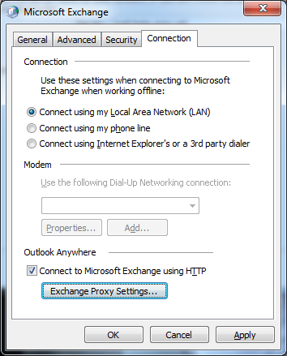

- Configure the settings below:
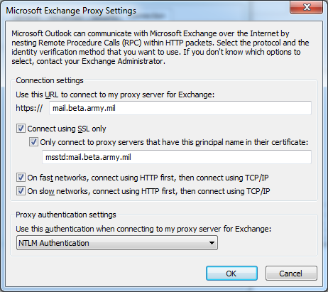

- Click OK twice

- Click on Check Name
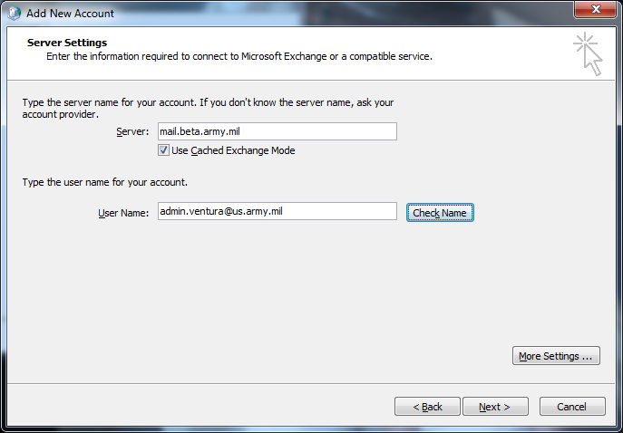

- At the logon window enter your Beta Mail account credentials. For username enter pilot\username with your Beta Mail account password.
NOTE: If the @us.army.mil alias is added to the username, remove it

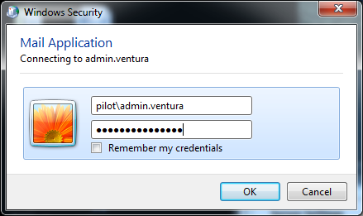

- The Server Name and User Name should be underlined if the account was verified on the server. Click Next

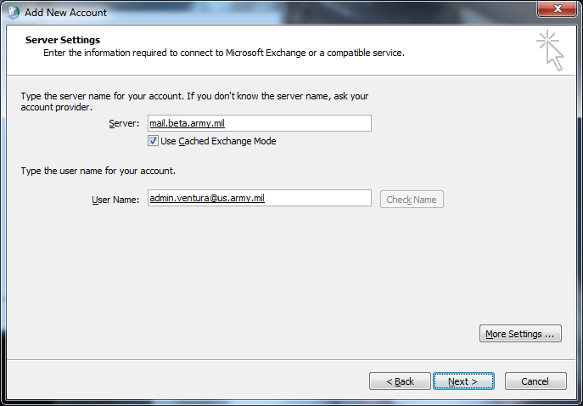

- If the account was setup successfully, you will get the window below and click Finish
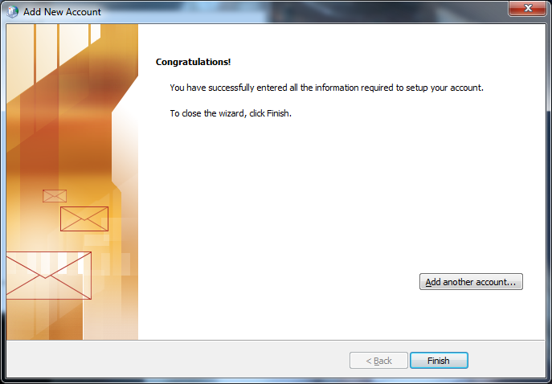

- Launch Outlook and logon to the profile configured for your Beta Mail account.

Questions regarding using your CAC on your personal computer can be found at: https://MilitaryCAC.com

